Presentaiton of the crop management interface for D4Declic

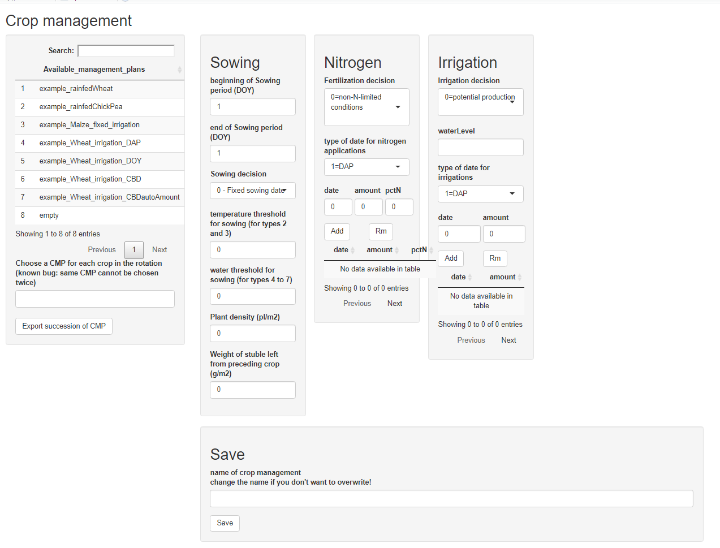

1. Select a crop management on the left to see its content (DO NOT SELECT “empty” – it crashes with the last version, I need to find why). There’s also a bug to visualize the type of date for irrigation for some of the already-provided crop management plans.
2. You can change the sowing, nitrogen, irrigation options (to add new fertilisation/irrigations, enter the date, amount and %N and click “add”, you can also remove some dates by selecting the lines in the table below and click on “Rm”
3. After you are done defining the CMP, give it a new name (or an existing name to overwrite) and click on “Save” at the bottom
4. After you have created or modified all the CMP you want, choose one or several crop managements (already existing or newly created)in the box “choose CMP for each crop in the rotation” (autocompletion allows quickly choosing CMP by typing a few letters from its name) and click on « export » to generate the json file. (is is created as (inputpath)/CMPfromUser.json")

